**Introduction**

In today’s modern world, advancements of technology and excessive use of various source of energy has affected the environment and led to serious changes in climate. One of the main contributors to this change, are carbon emissions from different sectors all over the world. This has added to the importance of monitoring and finding solutions to reduce carbon emissions. In this context, retail buildings significantly contribute carbon emission due to various reasons, including high consumption of energy for lighting, HVAC and refrigeration systems, waste generation and operational activities.

However, many retail businesses are not equipped with effective tools to assess and manage their carbon footprint. Therefore, this project is a tool developed for this specific purpose. The stakeholders of this projects are commercial building owners and managers, who play a crucial rule in implementing methods for emission reduction, and have access to necessary data. Also, tenants can affect the energy consumptions and waste productions and will benefit from lower operating costs while getting known as environmentally friendly businesses. Responsible authorities can also impact the process by ensuring compliance with the set standards. Finally, costumers and the local communities will benefit from the reduction of environmental impacts and can also learn about the importance of it and seek ways to reduce their own carbon footprint.

This project based on three factors including monthly energy use, waste production and recycling, and business travels, calculates the annual carbon emission related to each of these factors, compares it to the benchmark and in case of excessive emission, suggests solutions to alleviate the situation. In the end, each company’s data regarding every factor is compared to others and shown in bar charts. These bar charts also allow the users to see the trend in carbon emissions in retail buildings. At the end the user can download the report with all the data and recommendations in it.

This project is developed using Python programming language and Streamlit library for the web framework. The Link to the Github repository is provided here:

https://github.com/parisakh4/Python-project-carbon-footprint

**Code Overview**

The code consists of four main parts:

* Import and Dependencies
* Utility Functions
* Classes
* Main Function

**Imports and Dependencies**

At the beginning of the code necessary libraries and modules are imported, including Streamlit for the web interface, Pandas for manipulating the data, Plotly for creating charts and Reportlab for PDF generation.

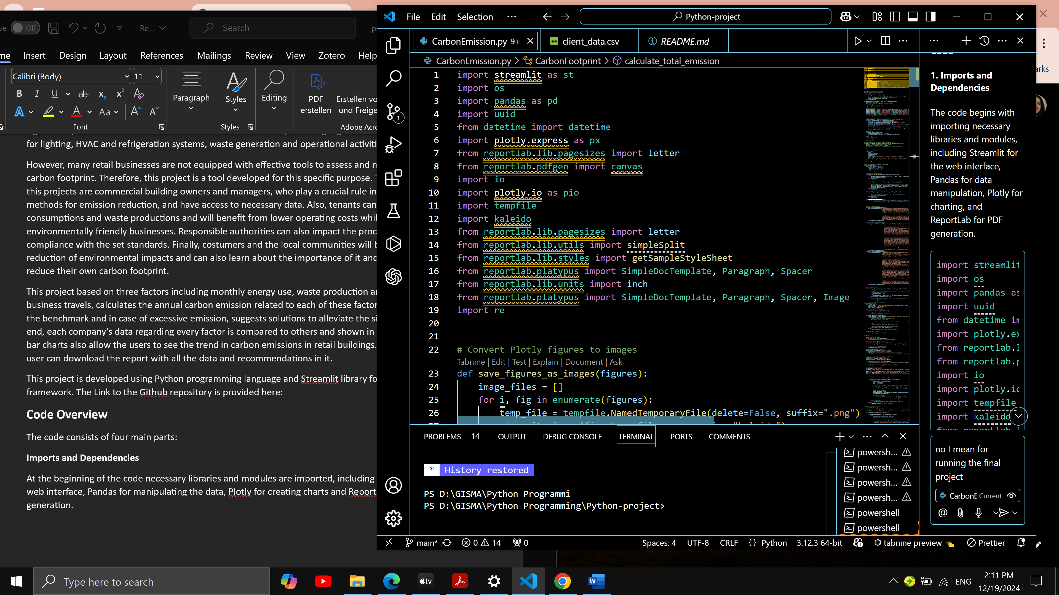

**Utility Functions**

The next part of the code includes utility functions to handle tasks such as generating charts and PDFs and converting charts to images. This function was needed for putting the Plotly charts on the PDFs using Reportlab.

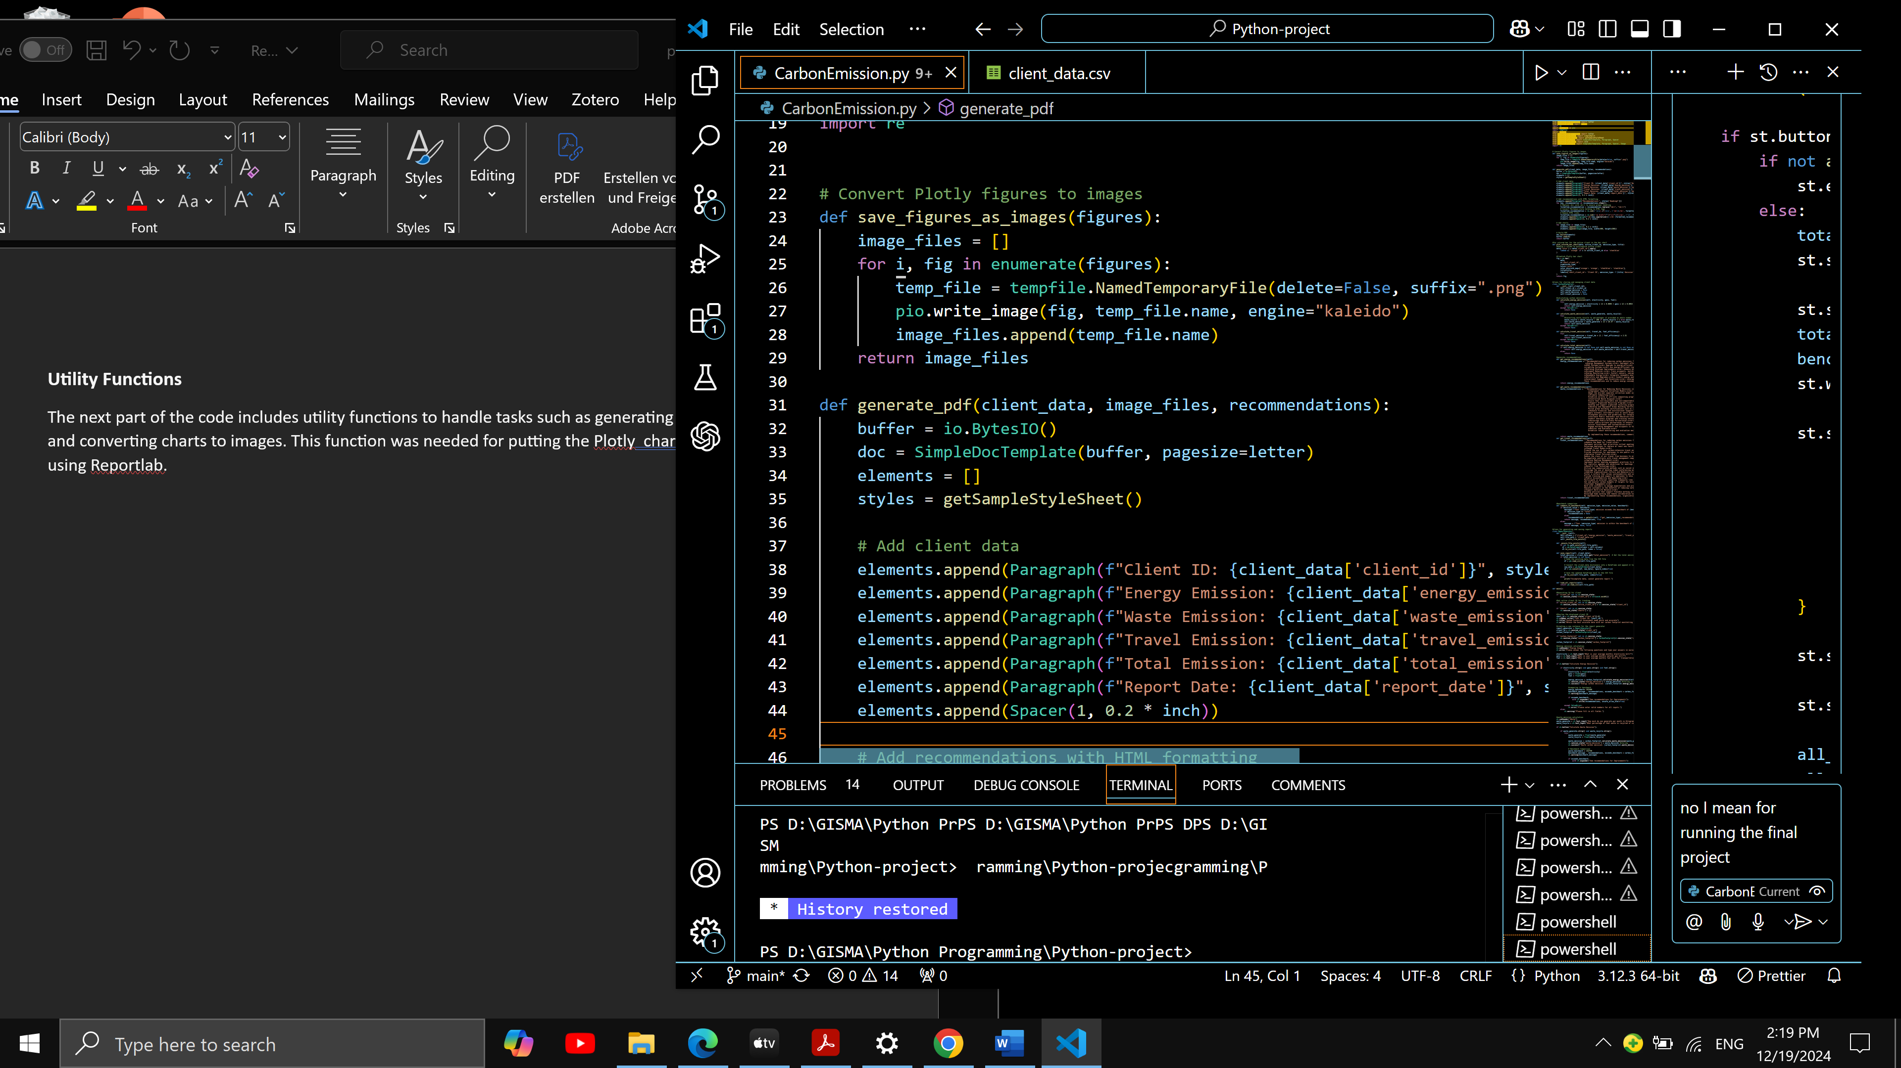

**Classes**

The next part of the code consist of classes to contain related functions and to make the code more modular. This way the code is easier to maintain and will have the potential for furthure development. The most important class is the CarbonFootprint that hanldes information input to calculate carbon emissions and comparing them to the benchmark. The next class is ReportGenerator that has the method for generating reoprts on the user data.

**CarbonFootprint Class**

This class four methods for calculating the emissions from energy usage, waste, bussiness travel and total emission. They are later called in the main part with the buttons.

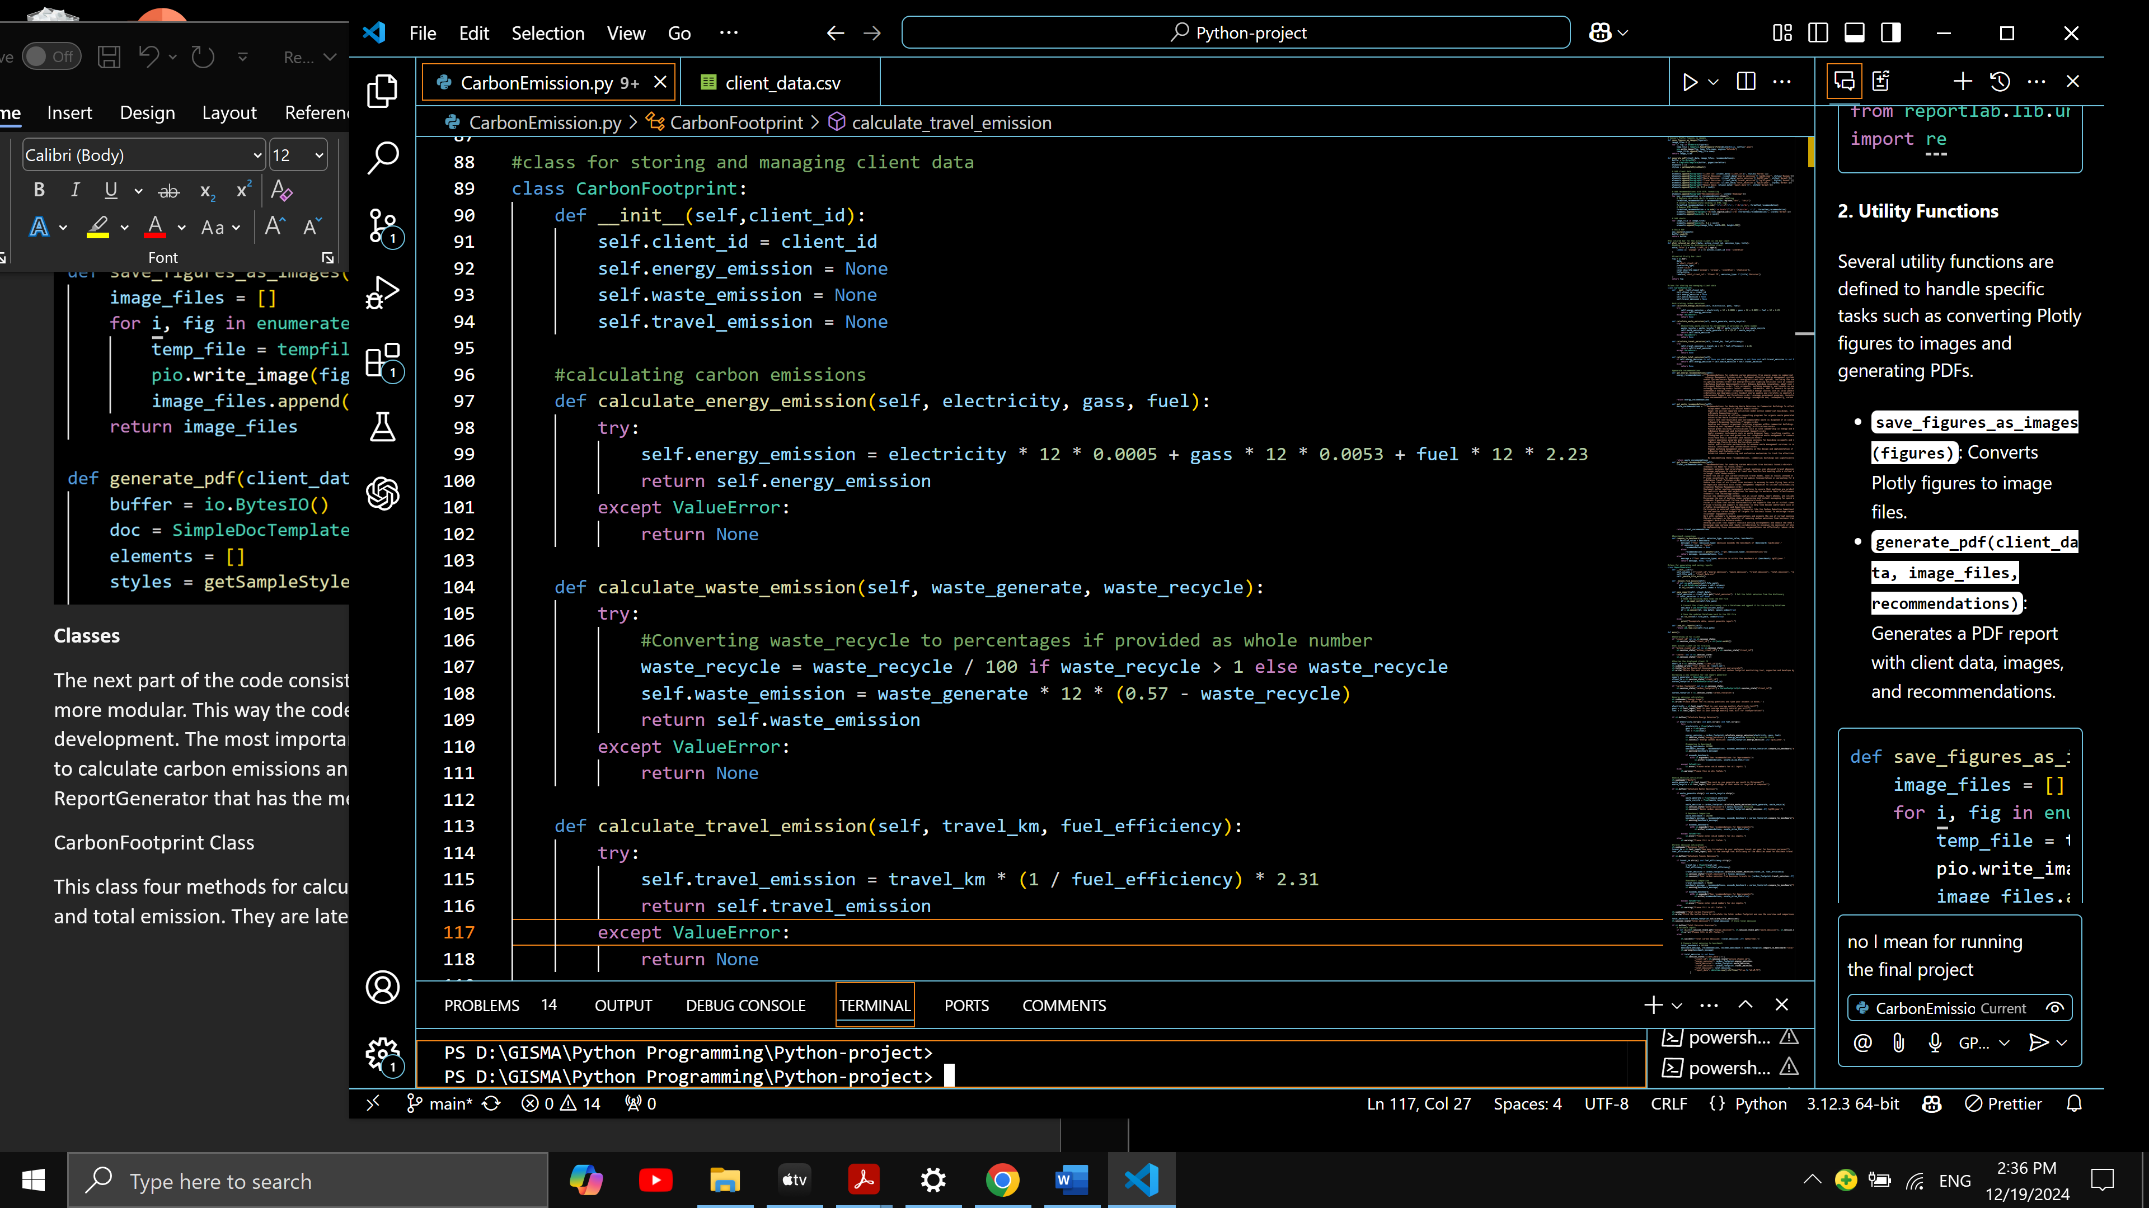

Additionaly, there are three methods for generating recommendations related to three mentioned carbon emission factors.

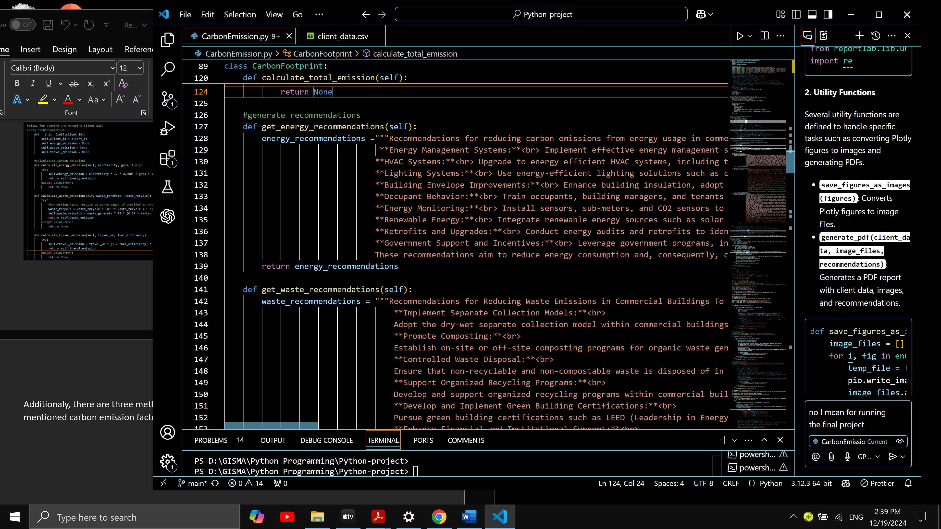

**The main function**

The main function initialises the Streamlit app, then with the use of buttons, calculates the emissions and shows the recommendations if needed. Also, it has a button for showing the user’s emission in bar charts in comparison to other customers and showing the trend across them. In the end there is a button for downloanding the PDF report.

Each of these button call functions that were defiened at the beginning. For instance, the “Calculate Energy Emission” Button checks if all the fields are filled correctly and then calls the calculate energy emission method from the CarbonFootprint class.

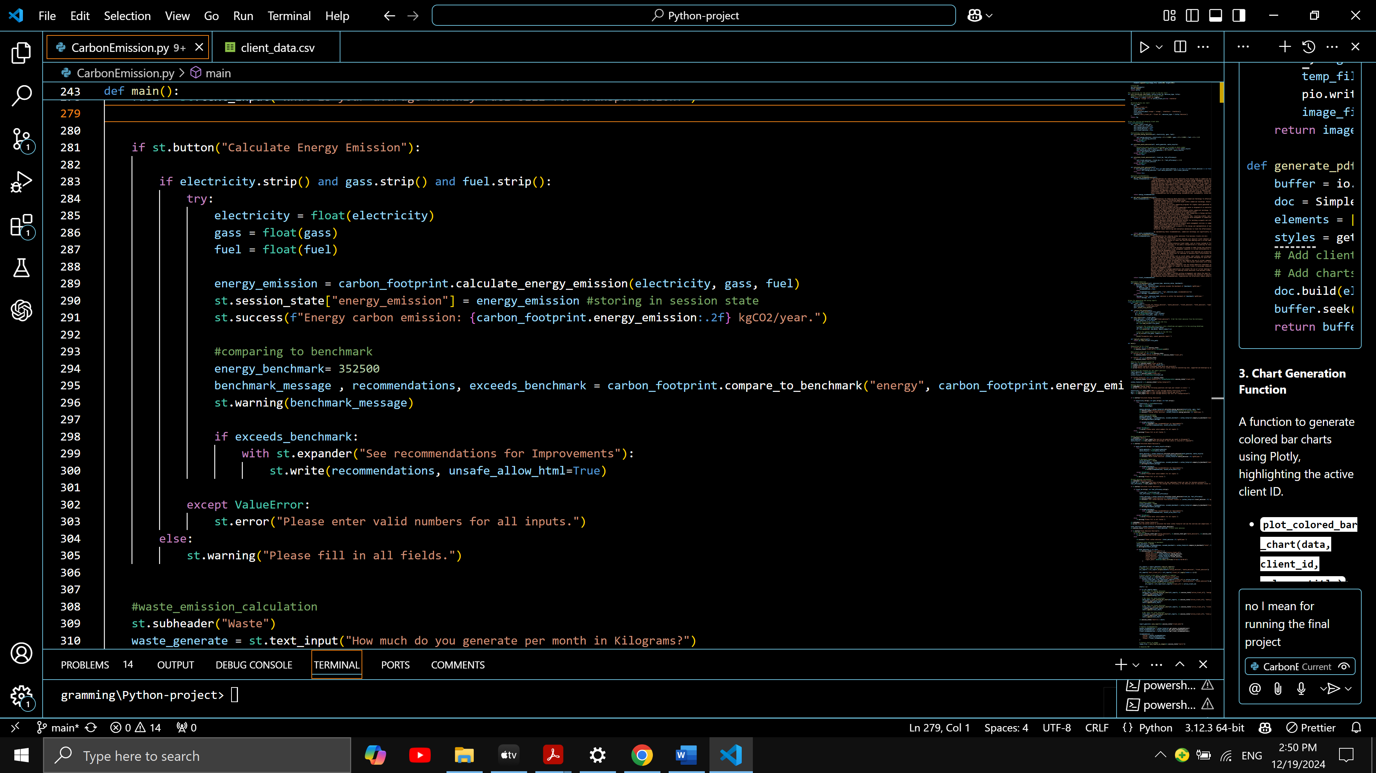

Below is one example of input and output. If the clients emission exceeds the benchmark, it will appear with the yellow message and then with a click on See recommendation expander, the user can see the recommendations.

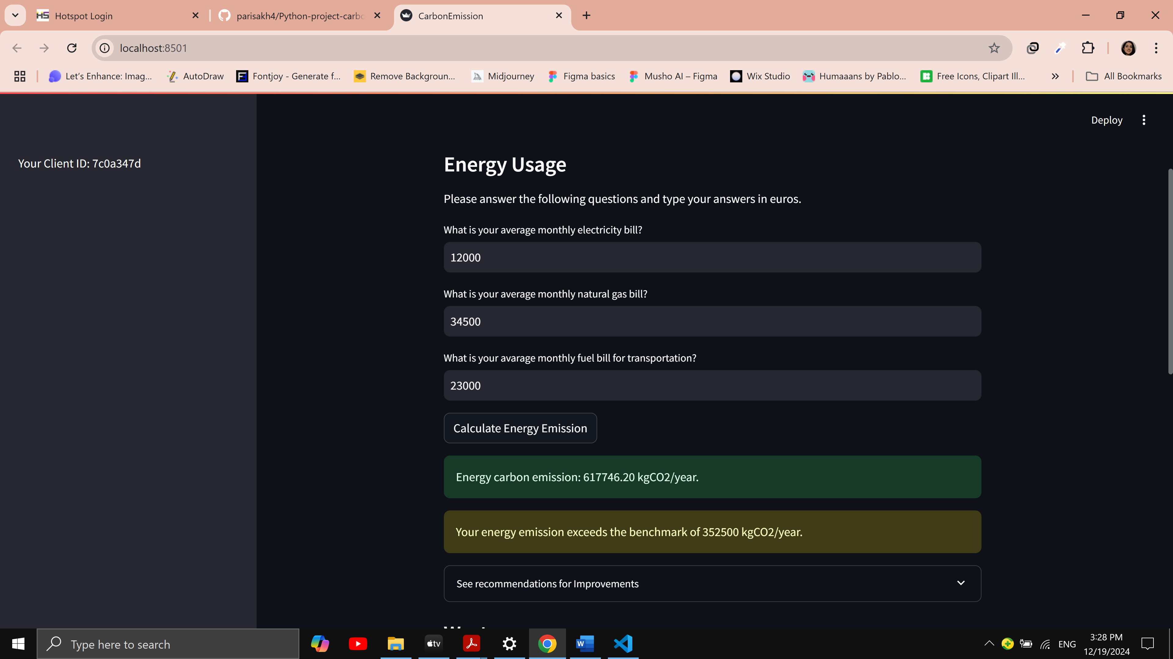

All the other emissions are calculated the same way and in the end, the button “Total Emission Overview” prints the total emissions and shows the charts. At the buttom of the charts the button for downloading the report is located.

The main function uses Streamlit session state to store client IDs, charts and other data to ensure the consistency and the state remaining the same across user interactions and preventing loss of data.

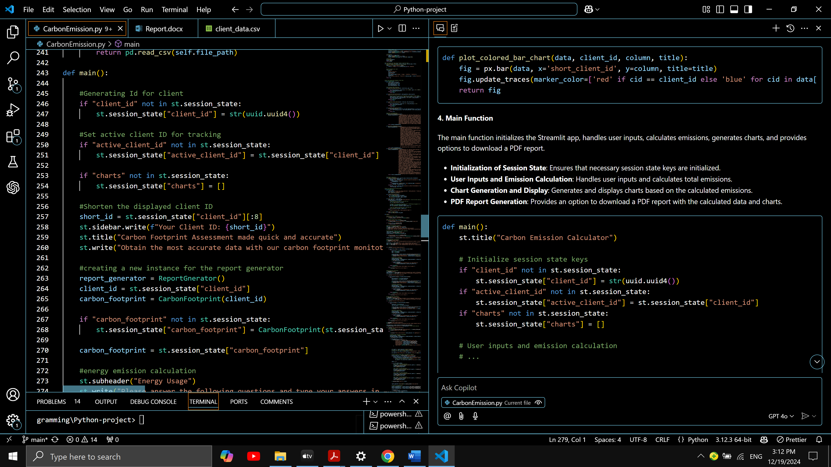

**Error Handling**

There are two main methods for handling errors and invalid data. First, with an if function it is checked weather all the boxes are filled. If not, a message is printed asking the user to fill all the forms. Second, with the use of Try-Except Blocks, the function checks if the data is valid and handles errors.

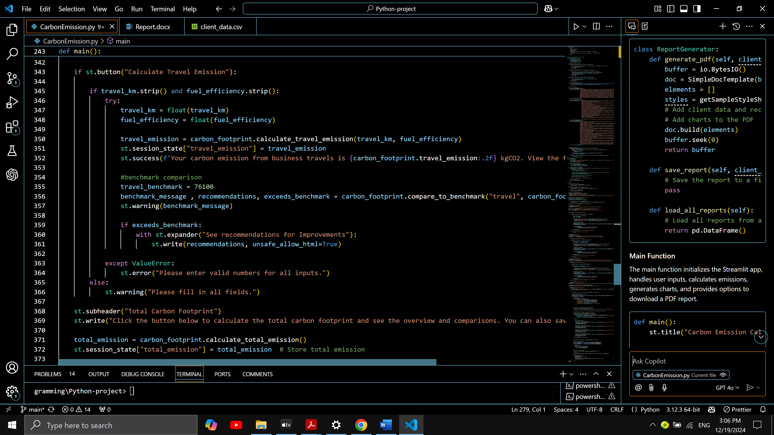

**Visuals and Analysis Summery**

As mentioned before, the data is shown in bar charts, with the current user bar highlited for clear visualization.

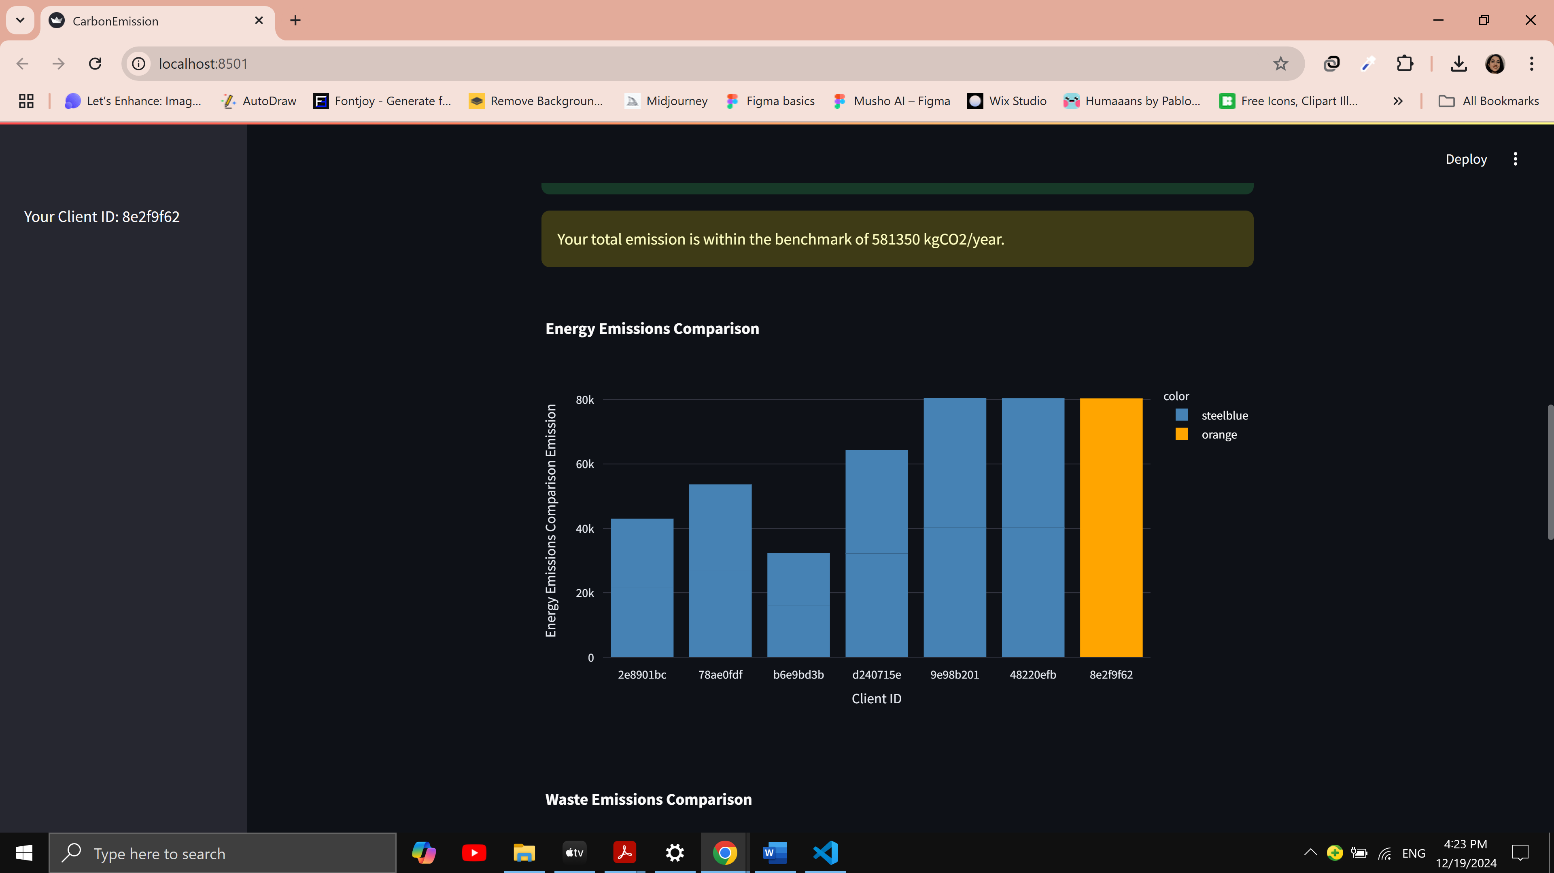

**Conclusion**

This project is an innitiation of an application to calculate Carbon Footprints for medium-sized retail buildings and give recommendations. Since carbon emission is a serious and consistent environmentall issue, it can be further developed to be more usefull and efficient. The future work can be developing functions to calculate the emissions more accurately, for example based on the total area of the buildings, their location and local carbon emission regulations. Furthermore, the data can be handled in more detailed and monthly emissions could also be calculated. This way each client can be able to track their carbon footprint and take measures to better manage it.